Cross-quantilogram: GBPUSD and USDCHF
Method 20 / daily log returns / expanding quantiles / Alpari D1 full available history

Study setup
Logical pair: GBPUSD , USDCHF
Broker symbols: GBPUSD_i , USDCHF_i
Snapshot: 2026-11-03_majors_alpari_D1
Timeframe: D1
Matched return window: 1999-01-05 to 2026-11-02 (UTC bar dates)
Matched return count n: 7201
Dropped unfinished last bar dated 2026-11-03 UTC after a tick-volume check against the prior complete day.
Quantiles: expanding window, min history 252 days
tau in [0.05, 0.2]; k=0..10; headline tau=0.05, k=1
Complete matched rows (Excel): GBPUSD-USDCHF_CQ_D1.xlsx
Complete matched rows (HTML table): GBPUSD-USDCHF_CQ_D1_data.html

Method carried forward
The cross-quantilogram rho_tau(k) measures linkage among centered quantile-hit indicators of matched daily log returns of close, ln(close_t / close_t-1). Quotes are not inverted. At each date t, the tau-quantile uses only returns through t (expanding window) after a minimum history of 252 days. Hits are h_t = 1(r_t < q_t) - tau. rho_tau(k) is the normalized cross-product of h_x,t with h_y,t+k. Levels tau in {0.05, 0.20} and lags k=0..10 are pre-specified; headline is tau=0.05, k=1 both directions. Same-sample Pearson r is a side check. This is not causation and not a trading signal.

Results (headline)
rho_GBPUSD->USDCHF(tau=0.05,k=1): -0.000099
rho_USDCHF->GBPUSD(tau=0.05,k=1): 0.017990
rho_GBPUSD->USDCHF(tau=0.20,k=1): -0.001722
rho_USDCHF->GBPUSD(tau=0.20,k=1): 0.045271
Pearson r: -0.486083

CQ table (tau=0.05)
k | rho_GBPUSD_to_USDCHF | n_GBPUSD_to_USDCHF | rho_USDCHF_to_GBPUSD | n_USDCHF_to_GBPUSD
0 | -0.03627006 | 6950 | -0.03627006 | 6950
1 | -9.949e-05 | 6949 | 0.01799048 | 6949
2 | 0.01436357 | 6948 | 0.02159963 | 6948
3 | 0.01797272 | 6947 | 0.03606303 | 6947
4 | 0.03605432 | 6946 | 0.01796384 | 6946
5 | 0.01433683 | 6945 | 0.03242748 | 6945
6 | 0.01794608 | 6944 | 0.04327322 | 6944
7 | 0.02903052 | 6943 | -0.00015377 | 6943
8 | 0.03264717 | 6942 | 0.02878301 | 6942
9 | 0.02538745 | 6941 | 0.04324728 | 6941
10 | 0.0435062 | 6940 | 0.05047522 | 6940

Conclusion
Headline tau=0.05, k=1 for GBPUSD and USDCHF: rho_GBPUSD->USDCHF = -0.0001; rho_USDCHF->GBPUSD = 0.0180. At tau=0.20, k=1: -0.0017 and 0.0453. Same-day tau=0.05 rho(k=0) = -0.0363. Pearson r = -0.4861. This is quantile-hit linkage, not a trading signal.

Charts
Daily closes

Daily log returns

Cross-quantilogram tau=0.05
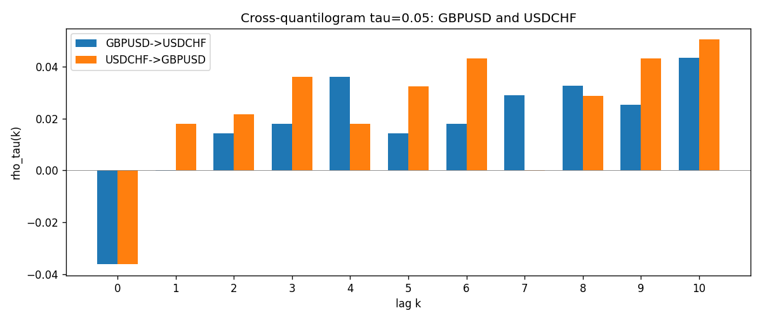

Data report
Matched rows and the CQ sheet are in the sibling Excel workbook named GBPUSD-USDCHF_CQ_D1.xlsx. Embedding all rows as a Word table is impractical; this file holds column summaries and the first and last 15 matched rows.
Columns: time, GBPUSD_open, USDCHF_open, GBPUSD_high, USDCHF_high, GBPUSD_low, USDCHF_low, GBPUSD_close, USDCHF_close, GBPUSD_tick_volume, USDCHF_tick_volume, GBPUSD_spread, USDCHF_spread, GBPUSD_real_volume, USDCHF_real_volume, GBPUSD_log_return, USDCHF_log_return, GBPUSD_h_t005, USDCHF_h_t005
Column summaries (matched calculation rows)
column | count | mean | std | min | 25% | 50% | 75% | max
GBPUSD_open | 7201 | 1.5160785 | 0.218271 | 1.06854 | 1.32499 | 1.51142 | 1.63167 | 2.1066
USDCHF_open | 7201 | 1.0982956 | 0.25264095 | 0.72022 | 0.92069 | 0.99019 | 1.2387 | 1.8219
GBPUSD_high | 7201 | 1.5223771 | 0.21884011 | 1.08366 | 1.32979 | 1.5182 | 1.6384 | 2.1161
USDCHF_high | 7201 | 1.1035944 | 0.25438893 | 0.73305 | 0.92495 | 0.99377 | 1.2436 | 1.8313
GBPUSD_low | 7201 | 1.5097512 | 0.21749696 | 1.03518 | 1.31949 | 1.50336 | 1.6244 | 2.0983
USDCHF_low | 7201 | 1.0931703 | 0.25105533 | 0.08565 | 0.91742 | 0.9867 | 1.2331 | 1.8121
GBPUSD_close | 7201 | 1.5161456 | 0.2182303 | 1.06879 | 1.3251 | 1.5114 | 1.63212 | 2.1065
USDCHF_close | 7201 | 1.0982864 | 0.25254184 | 0.72025 | 0.92098 | 0.9902 | 1.2387 | 1.8217
GBPUSD_tick_volume | 7201 | 94828.085 | 153546.21 | 62 | 10002 | 52900 | 91806 | 1273370
USDCHF_tick_volume | 7201 | 74189.26 | 113409.95 | 18 | 12770 | 40195 | 70240 | 858589
GBPUSD_spread | 7201 | 26.971115 | 19.193539 | 0 | 11 | 20 | 50 | 50
USDCHF_spread | 7201 | 26.114567 | 24.723753 | 0 | 5 | 16 | 50 | 100
GBPUSD_real_volume | 7201 | 3.5560898e+09 | 8.4438214e+10 | 0 | 0 | 0 | 0 | 2.4038164e+12
USDCHF_real_volume | 7201 | 2.3236557e+10 | 8.9041498e+10 | 0 | 0 | 0 | 0 | 1.9331921e+12
GBPUSD_log_return | 7201 | -2.316e-05 | 0.00564524 | -0.08388241 | -0.00312969 | 3.242e-05 | 0.00318104 | 0.03112653
USDCHF_log_return | 7201 | -7.148e-05 | 0.00659332 | -0.19545699 | -0.00335964 | 8.06e-05 | 0.00331782 | 0.09051364
GBPUSD_h_t005 | 6950 | 0.00122302 | 0.22046818 | -0.05 | -0.05 | -0.05 | -0.05 | 0.95
USDCHF_h_t005 | 6950 | -0.01661871 | 0.17964306 | -0.05 | -0.05 | -0.05 | -0.05 | 0.95
First 15 matched rows (selected columns)
time | GBPUSD_log_return | USDCHF_log_return | GBPUSD_h_t005 | USDCHF_h_t005
1999-01-05 | -0.0028966287 | 0.0039424743 | nan | nan
1999-01-06 | -0.00060452184 | 0.013605652 | nan | nan
1999-01-07 | -0.002118709 | -0.0093883841 | nan | nan
1999-01-08 | -0.0058954193 | 0.011040268 | nan | nan
1999-01-11 | -0.0056851331 | 0.0052963193 | nan | nan
1999-01-12 | 0.0022657001 | -0.0098275602 | nan | nan
1999-01-13 | 0.0091330396 | -0.018259701 | nan | nan
1999-01-14 | 0.0019376331 | -0.0024256692 | nan | nan
1999-01-15 | -0.0017558204 | 0.01794228 | nan | nan
1999-01-18 | 0.0012112405 | -0.0031856384 | nan | nan
1999-01-19 | 0.0018745281 | -7.2518946e-05 | nan | nan
1999-01-20 | -0.0049053846 | 0.0072259871 | nan | nan
1999-01-21 | 0.0031518998 | -0.0038232689 | nan | nan
1999-01-22 | 0.0024781662 | -0.0001445609 | nan | nan
1999-01-25 | 0.0012066366 | 0.0024546976 | nan | nan
Last 15 matched rows (selected columns)
time | GBPUSD_log_return | USDCHF_log_return | GBPUSD_h_t005 | USDCHF_h_t005
2026-10-13 | 0.0036434319 | -0.0024955621 | -0.05 | -0.05
2026-10-14 | -0.0049164679 | 0.0029388325 | -0.05 | -0.05
2026-10-15 | 0.0065976411 | -0.0097855323 | -0.05 | -0.05
2026-10-16 | 0.0037592051 | -0.0036230826 | -0.05 | -0.05
2026-10-19 | -0.0017500314 | 0.0036351779 | -0.05 | -0.05
2026-10-20 | 0.0055923442 | -0.0026281224 | -0.05 | -0.05
2026-10-21 | 0.0012476328 | -0.00040027413 | -0.05 | -0.05
2026-10-22 | 0.00022396082 | -0.0048036381 | -0.05 | -0.05
2026-10-23 | -0.0021146949 | 0.005652514 | -0.05 | -0.05
2026-10-26 | -0.0024340661 | 0.0018407959 | -0.05 | -0.05
2026-10-27 | -0.0023648393 | 0.0026100526 | -0.05 | -0.05
2026-10-28 | 0.0015771808 | -0.0010142111 | -0.05 | -0.05
2026-10-29 | 0.0035881935 | -0.0048680164 | -0.05 | -0.05
2026-10-30 | 0.0013450605 | 0.00071594559 | -0.05 | -0.05
2026-11-02 | 0.0010971256 | -0.0071459744 | -0.05 | -0.05

